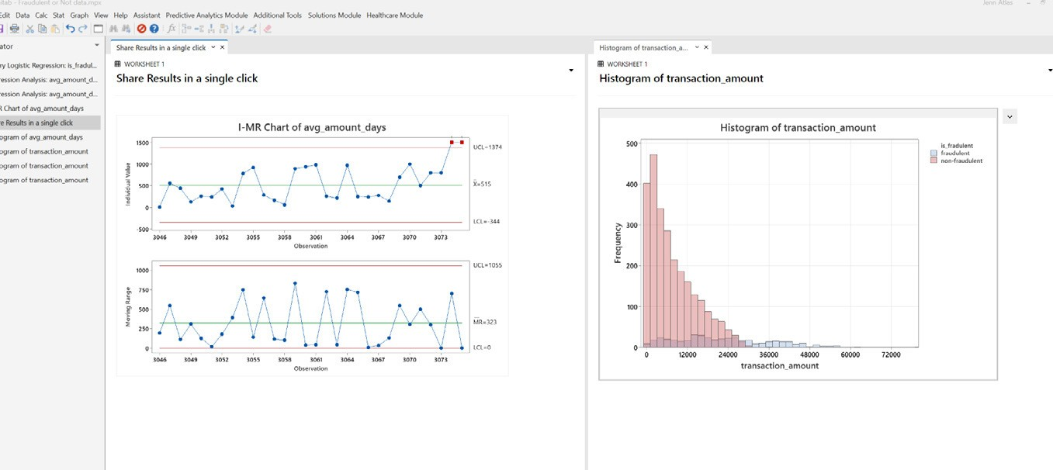

Harness the Power of Statistics
Minitab empowers all parts of an organization regardless of analytical background or geographic location through our comprehensive set of statistical tools for exploring data, illustrating insights, and predicting future trends with lightning speed.
Minitab Statistical Software can visualize, analyze, and harness the power of your data to solve your toughest challenges from anywhere on the cloud.

5 Reasons to Consider Minitab
- Intuitive Interface
- Comprehensive Collection of Methods
- Accessible Wherever you Are
- Seamless Deployment, Training, and Support
- Market-Leading Solutions Analytics Ecosystem

“There was a lot of hesitance from one of our customers to switch to Minitab Statistical Software, but Minitab’s sales and solutions teams quickly alleviated any concerns. Minitab was the ideal solution to deploy the global manufacturer’s OPEX program. Our solutions engineers and analyt- ics consultants provided deployment and training support to thousands of users across the globe in their local language. This was the best customer support the customer has ever seen!”

-Jim Oskins, Engineer with experience across automotive and consumer goods
“Minitab has been trusted for more than 50 years to provide expert analyses. Now you can get needed answers from new data automatically, and instantly share results. How much time can you save by answering challenging questions from leadership before they are even asked?”

– Rob Lievense, Experienced Quality leader across pharmaceuticals and manufacturing

Download your free 30-day trial today:
Get Started - Free Trial Download | Statistical & Data Analysis Software | Minitab

